WEEK 1 – Code Quality & Microservices with Springboot 3 - 7995206

EXERCISE 1: Creating Microservices for account and loan
Task: In this hands on exercises, we will create two microservices for a bank. One microservice for handing accounts and one for handling loans. Each microservice will be a specific independent Spring RESTful Webservice maven project having it's own pom.xml. The only difference is that, instead of having both account and loan as a single application, it is split into two different applications. These webservices will be a simple service without any backend connectivity. Follow steps below to implement the two microservices:
Account Microservice
Loan Microservice

Step-by-Step Solution:
1. Account.java
package com.cognizant.account.model;

public class Account {

private String number;
private String type;
private double balance;

public Account() {
}

public Account(String number, String type, double balance) {
this.number = number;
this.type = type;
this.balance = balance;
}

public String getNumber() {
return number;
}

public void setNumber(String number) {
this.number = number;
}

public String getType() {
return type;
}

public void setType(String type) {
this.type = type;
}

public double getBalance() {
return balance;
}

public void setBalance(double balance) {
this.balance = balance;
}
}
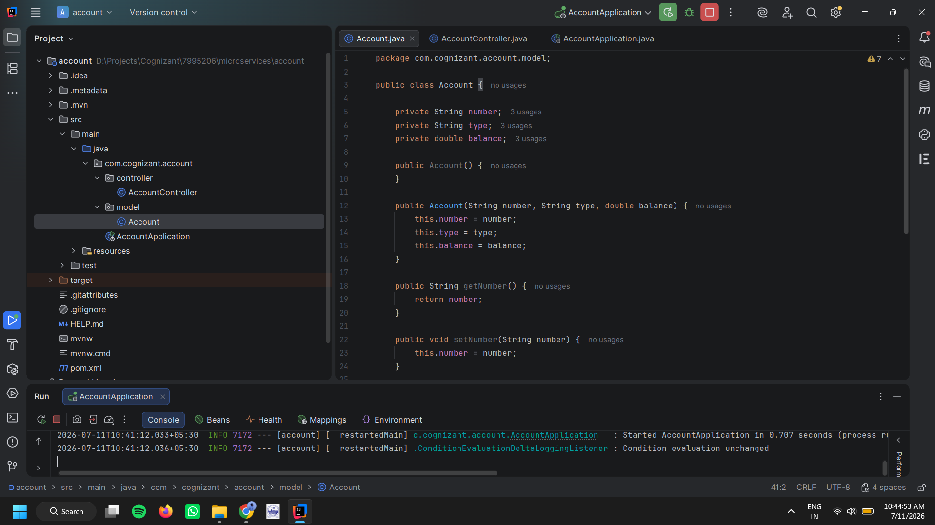

2. AccountController.java
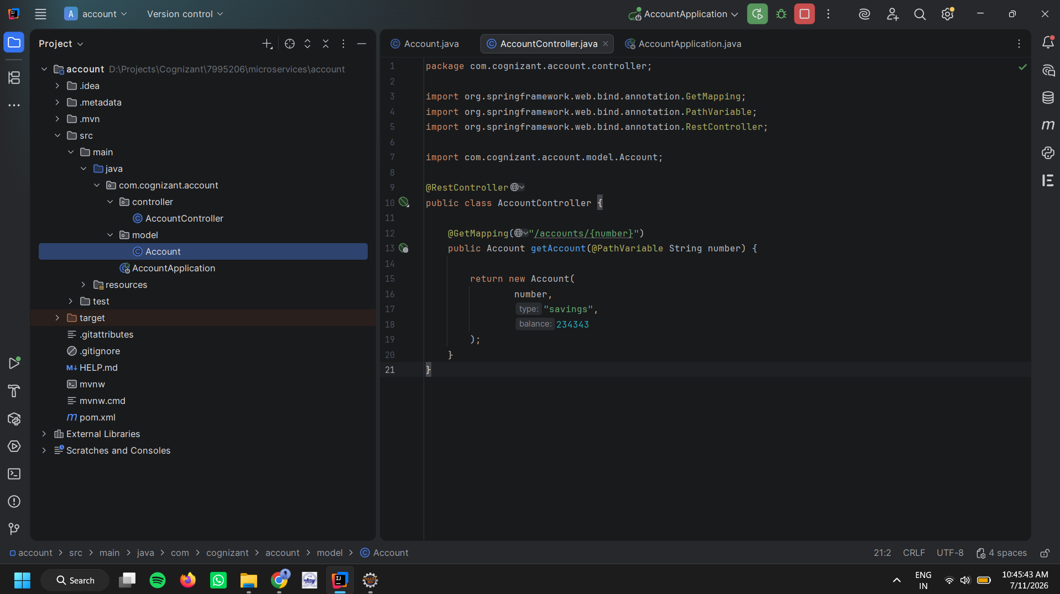
package com.cognizant.account.controller;

import org.springframework.web.bind.annotation.GetMapping;
import org.springframework.web.bind.annotation.PathVariable;
import org.springframework.web.bind.annotation.RestController;

import com.cognizant.account.model.Account;

@RestController
public class AccountController {

@GetMapping("/accounts/{number}")
public Account getAccount(@PathVariable String number) {

return new Account(
number,
"savings",
234343
);
}
}

Loan.java
package com.cognizant.loan.model;
public class Loan {
private String number;
private String type;
private double loan;
private double emi;
private int tenure;
public Loan() {
}
public Loan(String number, String type, double loan, double emi, int tenure) {
this.number = number;
this.type = type;
this.loan = loan;
this.emi = emi;
this.tenure = tenure;
}
public String getNumber() {
return number;
}
public void setNumber(String number) {
this.number = number;
}
public String getType() {
return type;
}
public void setType(String type) {
this.type = type;
}
public double getLoan() {
return loan;
}
public void setLoan(double loan) {
this.loan = loan;
}
public double getEmi() {
return emi;
}
public void setEmi(double emi) {
this.emi = emi;
}
public int getTenure() {
return tenure;
}
public void setTenure(int tenure) {
this.tenure = tenure;
}
}
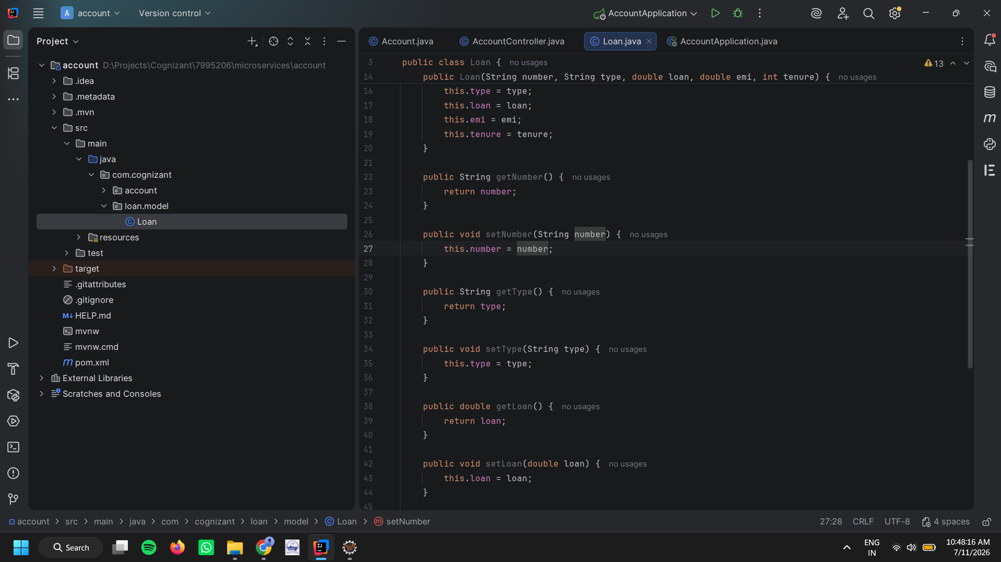

LoanController.java
package com.cognizant.loan.controller;
import org.springframework.web.bind.annotation.GetMapping;
import org.springframework.web.bind.annotation.PathVariable;
import org.springframework.web.bind.annotation.RestController;
import com.cognizant.loan.model.Loan;
@RestController
public class LoanController {
@GetMapping("/loans/{number}")
public Loan getLoan(@PathVariable String number) {
return new Loan(
number,
"car",
400000,
3258,
18
);
}
}

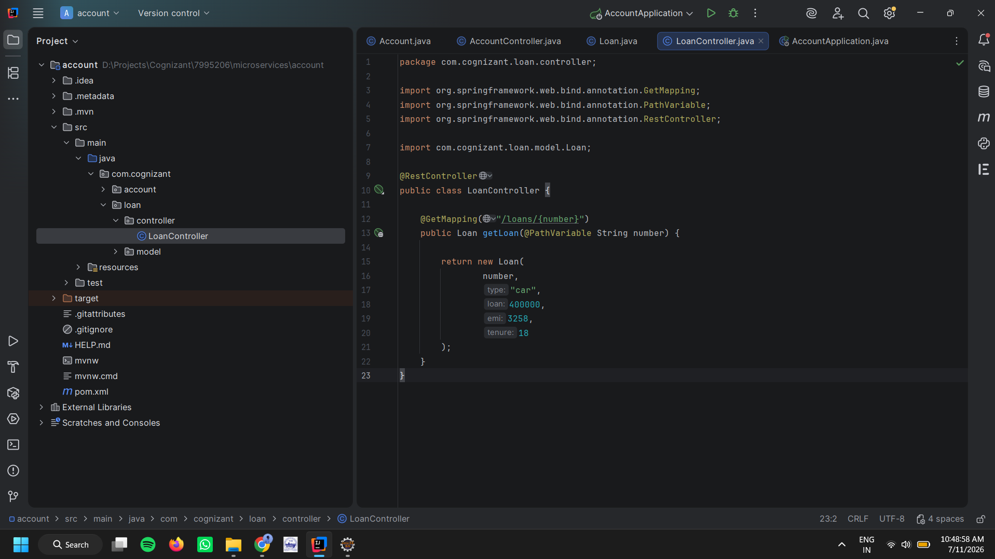
OUTPUT
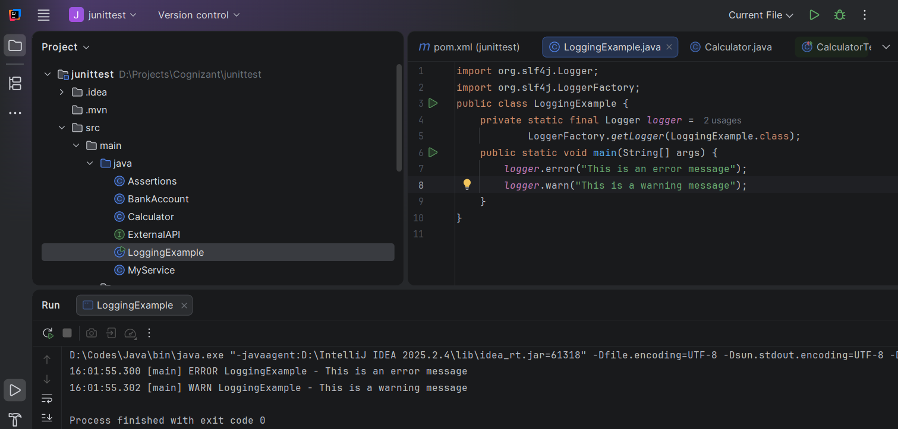

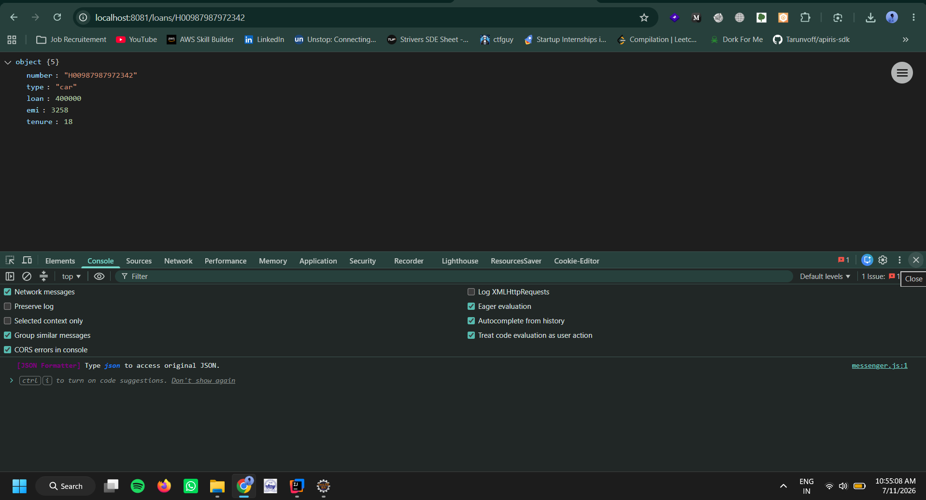

EXERCISE 2: Create Eureka Discovery Server and register

- Account.java

package com.cognizant.account.model;

public class Account {

private String number;
private String type;
private double balance;

public Account() {
}

public Account(String number, String type, double balance) {
this.number = number;
this.type = type;
this.balance = balance;
}

public String getNumber() {
return number;
}

public void setNumber(String number) {
this.number = number;
}

public String getType() {
return type;
}

public void setType(String type) {
this.type = type;
}

public double getBalance() {
return balance;
}

public void setBalance(double balance) {
this.balance = balance;
}
}

AccountController.ajva

package com.cognizant.account.controller;

import org.springframework.web.bind.annotation.GetMapping;
import org.springframework.web.bind.annotation.PathVariable;
import org.springframework.web.bind.annotation.RestController;

import com.cognizant.account.model.Account;

@RestController
public class AccountController {

@GetMapping("/accounts/{number}")
public Account getAccount(@PathVariable String number) {

return new Account(
number,
"savings",
234343
);
}
}

